Copeland Elementary School

**TIPS for a GREAT Start**

**Face2Face (Learn@Home) AND Online Learners**

***WELCOME*** back to the 2nd Semester of school! We hope you had a restful break and are ready to embark on this adventure with us. This year has been unlike any other yet FULL of new learning experiences for students, teachers, and families. The Faculty and Staff at Copeland are excited to partner with all community stakeholders to make the remainder of this school year awesome!

**~**Dr. Laurie P. Taylor, Principal

***As a Parent, HOW can I help?***

* Create a learning space for your child
* Review schedule in Infinite Campus Parent Portal
* Create a schedule for synchronous and asynchronous work to include:
  + Movement breaks every 15 - 30 minutes
  + Do a cardio activity during lunch break
* Practice logging into Canvas through Launch Pad
* Download Canvas student & parent app
* Monitor your child’s growth in Parent Portal
* Encourage your child to exercise regularly and establish healthy eating habits
* BE POSITIVE – your child will follow your cues
* Ask your child to share something about his/her day at dinner.

***BEFORE the First Day of School...***

* + Go back-to-school shopping with your teacher’s supply list
  + Attend the Virtual Recorded Open House
  + Log onto your computer
  + Log into [Launchpad](https://launchpad.classlink.com/rcboe) *
  + Locate and explore the Canvas App
  + Complete the [Learning with Canvas](https://www.rcboe.org/domain/15556) Orientation
  + Install the Microsoft Suite (found in the Microsoft 365 app in Launch Pad)
  + Expect your teacher to contact you (He/She will provide details on instructional materials and Quarter 2 Report Card pick-up January 11-13, 2021)
  + Explore your teacher’s webpage- make sure you know your assigned synchronous lesson time & day.

* If you need assistance with logging in

(Username and Password) – Contact the Teacher

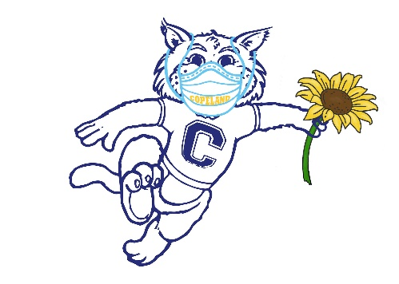

Before Tuesday, January 12, 2021 we recommend that students and parents complete the Canvas Orientations found at [rcboe.org/canvas](https://www.rcboe.org/canvas) if you haven’t already. We recommend that students send their teachers a practice message inside Canvas just to let the teacher know the student is ready for January 12, 2021. The orientations will give students and parents a high-level introduction to the features Canvas offers. The Communications department has shared orientation resources on the rcboe.org homepage and on social media. Those orientations can be found on the [rcboe.org/canvas](https://www.rcboe.org/canvas) webpage.

Parents are able to connect to their students’ accounts by “pairing.” This is something that parents will have to do, there is no automated process. In addition to the resources on our website, we wanted to provide you with the steps.

1. Parents are recommended to download the Canvas Parent app since most engage with Canvas from their phones. This will also allow them to receive notifications on their phones. It is free.

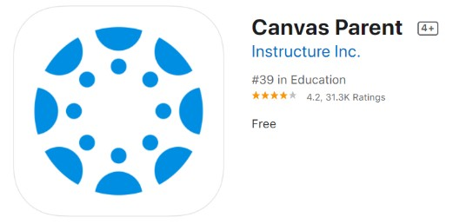

1. The student will log into his/her Canvas account through Launch Pad. Once in Canvas, they will click on their account (circle with silhouette or photo) and click **QR for Mobile Login.** This will generate a QR code that is valid for 10 minutes. The parent can scan the QR code from their Canvas Parent app. This will take the parent directly to the student’s page.

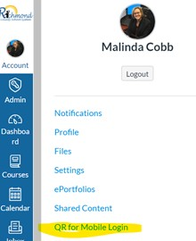

1. Next, the parent will be asked for the student’s pairing code. From the student’s account, the student will select Settings (see image above). In the Settings, there will be a button on the right side of the page called **Pair with Observer**. When the user presses this button, it will generate a short pairing code. The parent will enter this code in the app. The parent only has to do this process once for the child’s educational career (K-12).

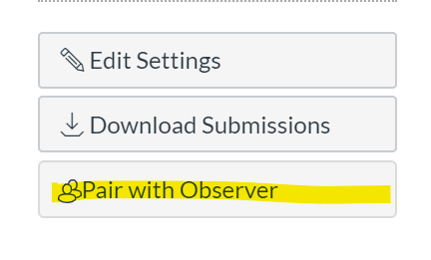

1. That’s it. The parent and student are now paired. They can repeat the same steps with pairing codes to add additional children if needed.
2. For directions using a Desktop or Laptop for pairing, please [click here.](https://www.rcboe.org/cms/lib/GA01903614/Centricity/Domain/15556/ParentLoginforCanvas.pdf) Parents will need to search for

**RCBOE Parents** in the menu.